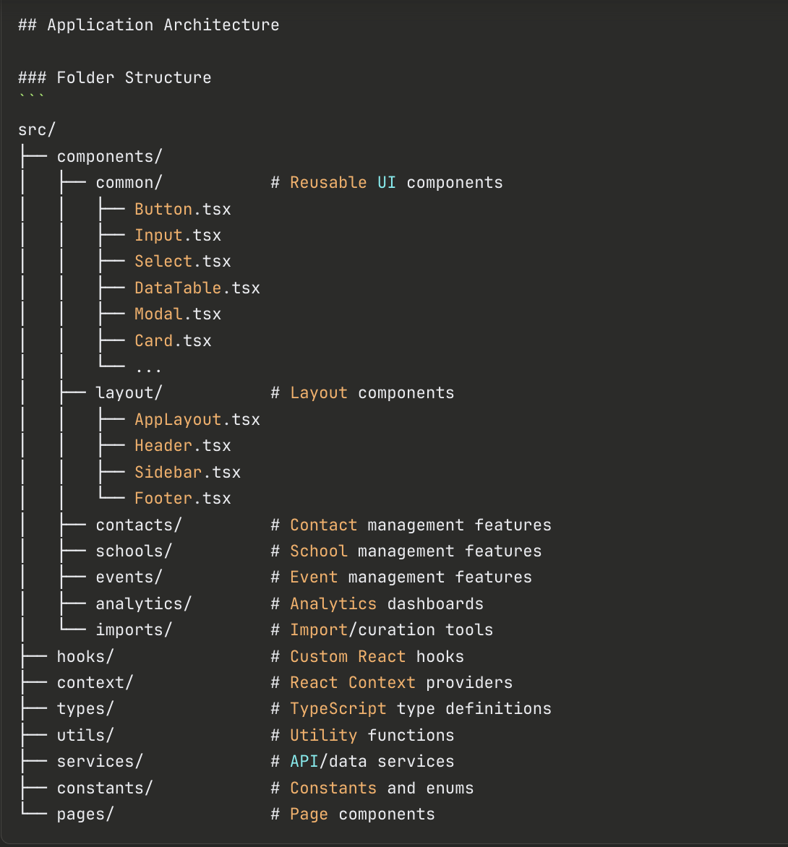

Core Data Models (TypeScript Interfaces)

Contact Interface
typescript
interface Contact {
id: string;
firstName: string;
lastName: string;
email: string;
phone?: string;
role: ContactRole;
schoolId: string;
isActive: boolean;
notes?: string;
createdAt: Date;
updatedAt: Date;
lastContactDate?: Date;
}

enum ContactRole {
SUPERINTENDENT = 'superintendent',
PRINCIPAL = 'principal',
COUNSELOR = 'counselor',
CS_TEACHER = 'cs_teacher',
ENGINEERING_TEACHER = 'engineering_teacher',
MATH_TEACHER = 'math_teacher',
SCIENCE_TEACHER = 'science_teacher',
}

School Interface
typescript
interface School {
id: string;
name: string;
district?: string;
county: string;
address: string;
city: string;
state: string;
zipCode: string;
schoolType: 'high_school' | 'middle_school';
contacts: Contact[];
activityHistory: ActivityRecord[];
isActive: boolean;
notes?: string;
createdAt: Date;
updatedAt: Date;
}

Event Interface
typescript
interface Event {
id: string;
name: string;
type: EventType;
date: Date;
location: string;
participatingSchools: string[]; // School IDs
attendeeCount?: number;
notes?: string;
createdAt: Date;
updatedAt: Date;
}

enum EventType {
OUTREACH_FAIR = 'outreach_fair',
CAMPUS_VISIT = 'campus_visit',
RECRUITMENT_EVENT = 'recruitment_event',
SUMMER_CAMP = 'summer_camp',
WORKSHOP = 'workshop',
OTHER = 'other',
}

Activity Record Interface
typescript
interface ActivityRecord {
id: string;
schoolId: string;
eventId?: string;
activityType: string;
date: Date;
description: string;
outcome?: string;
}

Feature Requirements
1. Contact Management Module
Input/Import Features
Components to Build:
- ContactImport.tsx - File upload interface (CSV, XLSX)
- ContactImportPreview.tsx - Preview table with data validation
- ContactForm.tsx - Add/edit individual contacts
- ContactCurationQueue.tsx - Review and validate imported contacts
Key Functionality:
- Drag-and-drop file upload with validation
- Column mapping interface (map spreadsheet columns to Contact fields)
- Duplicate detection (by email, name + school)
- Bulk validation indicators (invalid emails, missing required fields)
- Review queue with approve/reject/edit actions
- Web scraping results ingestion (paste structured data)
Validation Rules:
- Email format validation
- Phone number formatting (US format preferred)
- Required fields: firstName, lastName, email, role, schoolId
- Warn on duplicate emails within same school
Contact Curation Features
Components:
- ContactList.tsx - Searchable, filterable contact table
- ContactDetail.tsx - Full contact profile with edit capability
- BulkContactActions.tsx - Bulk operations UI
Features:
- Filter by: school, role, active status, last contact date
- Search by: name, email, school name
- Bulk actions: mark as inactive, export, delete
- Activity timeline per contact
- "Needs Update" flags (stale contacts, bounced emails)

2. School Management Module
Components:
- SchoolList.tsx - Searchable school directory
- SchoolDetail.tsx - School profile with contact roster
- SchoolForm.tsx - Add/edit school information
- SchoolParticipationImport.tsx - Upload event participation lists
Features:
- County-based filtering
- Search by school name, district, city
- View all contacts per school with role breakdown
- Activity history timeline per school
- Tag schools participating in specific events/camps
- Import participation lists (Excel/CSV) and link to existing schools

3. Event Management Module
Components:
- EventCalendar.tsx - Calendar view of all events
- EventList.tsx - Table view of events
- EventForm.tsx - Create/edit events
- EventDetail.tsx - Event details with participant list
Features:
- Create events with date, type, location
- Link participating schools to events
- Calendar views: month, week, list
- Export event participant lists (for mailings)
- Track attendance numbers
- Filter events by type, date range, county

4. Output Generation Module
Components:
- MailingListGenerator.tsx - Build mailing lists with filters
- EmailListGenerator.tsx - Build email lists with filters
- EventContactExport.tsx - Export contacts for specific events
Features:
- Filter builder UI with multi-select options:
  - By county
  - By school type
  - By contact role
  - By event participation
  - By activity level
- Preview contact list before export
- Export formats: CSV, Excel, formatted for mail merge
- Generate formatted mailing labels (PDF)
- Copy email list to clipboard (comma-separated)
Export Options:
- Mailing labels format (address blocks)
- Email list (emails only, one per line)
- Full contact list (all fields)
- Custom field selection

5. Analytics Dashboard Module
Components:
- AnalyticsDashboard.tsx - Main analytics container
- ActivityBySchoolChart.tsx - Bar/line chart component
- TrendAnalysisChart.tsx - Year-over-year comparison
- CountyHeatmap.tsx - Geographic distribution
- ActivityMetrics.tsx - KPI cards
- SchoolDataQualityReport.tsx - Data health indicators
- SuggestionEngine.tsx - AI-driven outreach suggestions
Analytics Features:
Activity by School by Year:
- Bar chart showing number of interactions per school
- Group by year, semester, or quarter
- Filter by county, school type, event type
- Sort by activity level (most to least active)
- Downloadable reports
Trend Analysis:
- Line chart comparing activity levels year-over-year
- Highlight schools with increasing/decreasing engagement
- Identify "at-risk" schools (declining activity)
- Growth metrics (% change year-over-year)
Data Quality Suggestions:
- Flag schools with outdated contact info (last updated > 1 year)
- Identify missing contacts by role (schools lacking a counselor contact, etc.)
- Highlight inactive contacts to remove
- County-based gap analysis (underserved counties based on goals)
- Suggest schools to prioritize based on engagement goals
Goal Tracking:
- Set engagement goals by county (e.g., "reach 80% of Madison County schools")
- Progress bars showing current vs. goal
- Prioritized outreach list based on goals
Metrics to Display:
- Total schools engaged (lifetime, this year)
- Total events hosted
- Average contacts per school
- Most common contact role
- Event participation rate
- Email deliverability rate
- Top 10 most engaged schools
- Top 10 underserved counties

User Interface Requirements
Navigation Structure
Sidebar Menu:
- 🏠 Dashboard (analytics overview)
- 🏫 Schools (school directory)
- 👥 Contacts (contact management)
- 📅 Events (event calendar)
- 📥 Import Data (import tools)
- 📤 Generate Lists (output generation)
- 📊 Analytics (detailed analytics)
- ⚙️ Settings
Page Layouts
Dashboard Page:
- Hero metrics cards (total schools, contacts, events)
- Recent activity feed
- Upcoming events widget
- Quick actions (add contact, create event, import data)
- Mini charts (activity trend, county distribution)
Schools Page:
- Search bar + filter chips
- Data table with columns: Name, County, Type, # Contacts, Last Activity, Status
- Quick actions per row: view, edit, export contacts
- Bulk select for batch operations
Contacts Page:
- Advanced filter panel (role, school, status, date range)
- Data table with columns: Name, Role, School, Email, Phone, Last Contact, Status
- Inline edit capability
- Export selected contacts
Events Page:
- Toggle between calendar and list view
- Filter by event type, date range
- Create event button (prominent)
- Past events section
Import Data Page:
- Tabbed interface: Contacts | Schools | Events
- Upload area with instructions
- Recent imports history
- Template download links
Generate Lists Page:
- Filter builder wizard
- Live preview of selected contacts
- Export format selector
- Download button

Data Management
Local Storage Strategy (For MVP)
- Use localStorage for persistence (migrate to backend later)
- IndexedDB for large datasets (if needed)
- Export/import full database (JSON backup)
State Management Pattern
typescript
// Example context structure
interface AppState {
schools: School[];
contacts: Contact[];
events: Event[];
filters: FilterState;
user: User;
}

File Upload Handling
CSV/Excel Import Flow
- User uploads file
- Parse file (use PapaParse for CSV, SheetJS for Excel)
- Display preview table (first 10 rows)
- Column mapping UI (if headers don't match exactly)
- Validation run (highlight errors in red)
- User reviews, fixes issues
- Confirm import → add to database
- Show success message with summary (X contacts added, Y duplicates skipped)
Validation Rules
- Email must be valid format
- Required fields cannot be empty
- Phone numbers formatted consistently
- Check for duplicates before import

Analytics Implementation
Chart Library: Recharts
Sample Charts:
- Activity by School: Horizontal bar chart
- Trend Analysis: Multi-line chart (year comparison)
- County Distribution: Pie/donut chart
- Event Participation: Stacked bar chart (school types)
Suggestion Algorithm (Simple)
- Flag schools with no activity in past 12 months
- Prioritize counties below goal threshold
- Identify schools missing key contact types
- Sort by county population + engagement gap

Deliverables Checklist
Phase 1: Core Structure
- Project scaffolding with Vite + TypeScript
- Tailwind configured with SIUE theme
- Basic routing setup (all pages)
- Layout components (header, sidebar, footer)
- Common UI components (Button, Input, Card, Modal)
Phase 2: Data Management
- TypeScript interfaces defined
- Context/state management setup
- LocalStorage persistence utilities
- Sample seed data
Phase 3: Features
- Contact import and curation
- School directory and detail pages
- Event calendar and management
- Output generation (mailing lists)
- Basic analytics dashboard
Phase 4: Polish
- Loading states and error handling
- Form validation
- Responsive design tweaks
- Accessibility audit
- User testing and feedback

